EXPT NO: 5 | IMPLEMENTATION OF A RECURRENT NEURAL NETWORK (RNN) FOR TEXT GENERATION
DATE: 24/08/26

PRE-LAB QUESTIONS (PROVIDE BRIEF ANSWERS TO THE FOLLOWING QUESTIONS)

- Explain the purpose of a Recurrent Neural Network (RNN) in processing sequential data.
A Recurrent Neural Network (RNN) is designed to process data where the order of elements matters, such as text, speech, or time-series data. Unlike a basic neural network, an RNN maintains a hidden state (memory) that carries information from previous steps to the current step. This allows it to learn patterns and relationships across a sequence.

- Why is an RNN considered an appropriate model for text generation tasks?
RNNs are suitable for text generation because text is sequential: the meaning of a word often depends on the words that came before it. An RNN can use previously processed words to predict the next word or character. By repeatedly making these predictions, it can generate text one element at a time while maintaining information about the preceding context.

- Describe the concept of sequence modeling in natural language processing.
Sequence modeling is the process of learning patterns and relationships within an ordered sequence of language elements, such as words or characters. In Natural Language Processing (NLP), sequence models can learn how words are related based on their position and surrounding context. Applications include language translation, speech recognition, sentiment analysis, and text generation.

- Explain the importance of tokenization during text preprocessing for RNN-based text generation.
Tokenization is the process of breaking text into smaller units called tokens, such as words, subwords, or characters. For example:
"I love AI" → ["I", "love", "AI"]
Tokenization is important because an RNN cannot directly process raw text. It needs the text to be divided into manageable units that can be assigned numerical representations. Good tokenization also helps maintain the meaningful structure of the text and makes it possible to train the model efficiently.

- Explain the significance of converting text into numerical representations before training an RNN.
RNNs perform mathematical operations on numbers, so text must be converted into numerical representations before training. Each token is typically mapped to an integer or represented as a vector, such as an embedding.
For example:
"I" → 1, "love" → 2, "AI" → 3
These numerical representations allow the RNN to identify patterns, learn relationships between tokens, calculate probabilities, and predict the next token. Without numerical encoding, the neural network cannot directly process or learn from textual data.

AIM
To implement a Recurrent Neural Network (RNN) for text generation and evaluate its ability to generate meaningful text by predicting the next word in a sequence.

SOFTWARE REQUIREMENTS
- Python
- TensorFlow or keras or PyTorch
- Google Colab
- GitHub
- Numpy
- Matplotlib

OBJECTIVES
Students will be able to:
- Understand the architecture and working of Recurrent Neural Networks (RNNs).
- Perform text preprocessing techniques for sequence modeling.
- Generate input sequences suitable for training an RNN model.
- Build and train an RNN model for text generation.
- Generate text by predicting the next word in a sequence.
- Evaluate the performance of the trained RNN using generated text.
- Analyze the effectiveness of RNNs in learning sequential patterns from textual data.

PROCEDURE
PART A: DATASET PREPARATION
Perform the following tasks:
- Load the Tiny Shakespeare dataset from Hugging Face.
- Explore the dataset and examine the text samples.
- Convert the text into lowercase (if required).
- Tokenize the text into individual words.
- Build a vocabulary and assign a unique integer index to each word.
- Generate input sequences for next-word prediction.
- Apply sequence padding to obtain inputs of equal length.
- Split the prepared sequences into training and validation datasets.

(CODE: CONATAINS STUDENT ROLL NOS
SCREENSHOT OF CODE
SCREENSHOT OF OUTPUT)

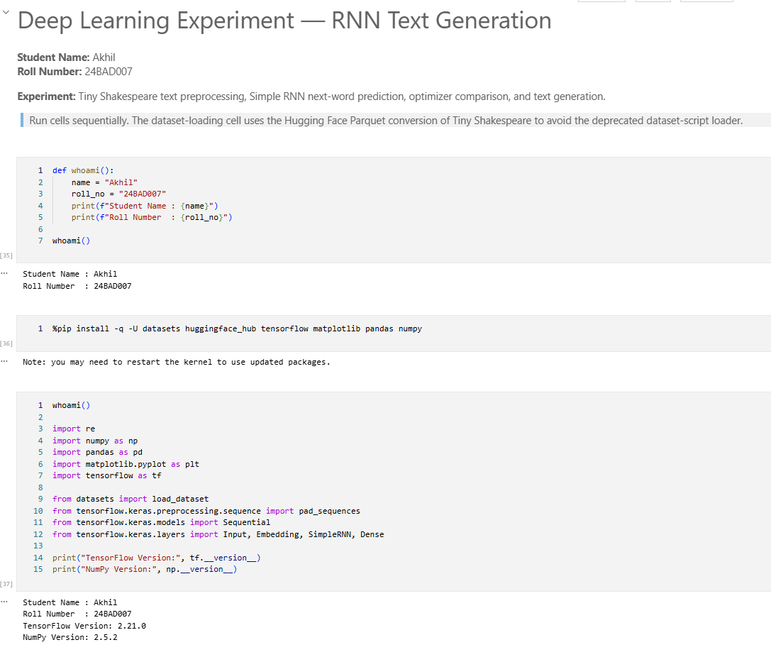
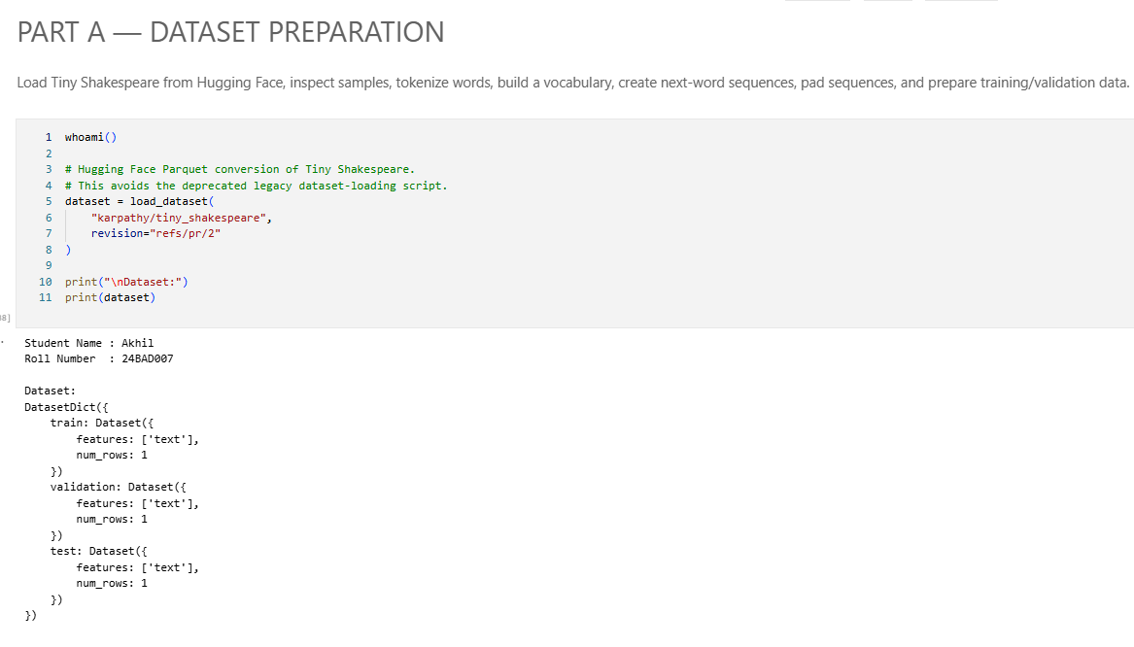
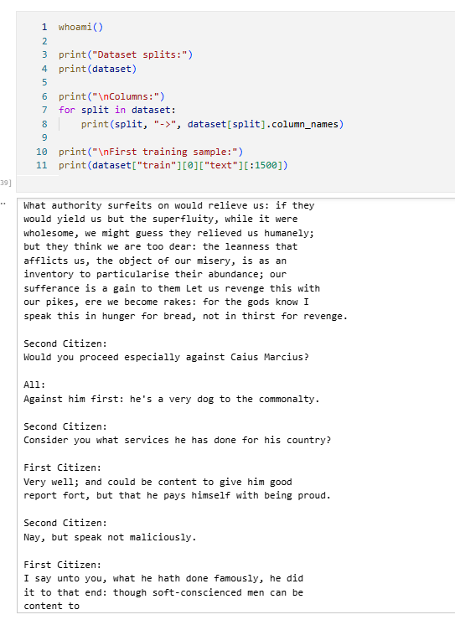
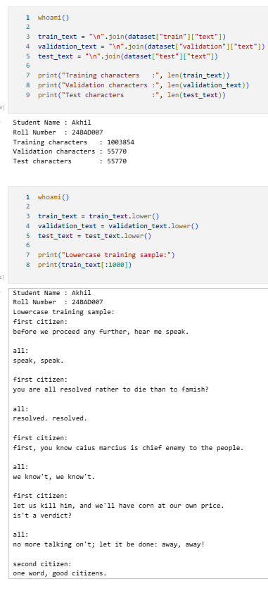
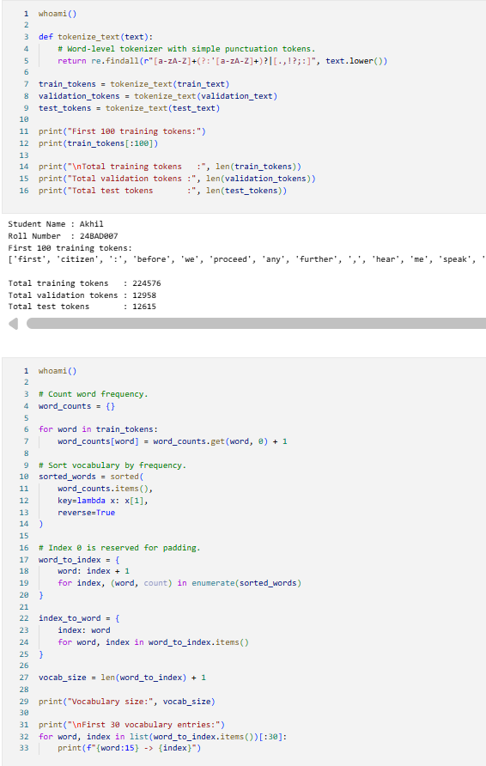
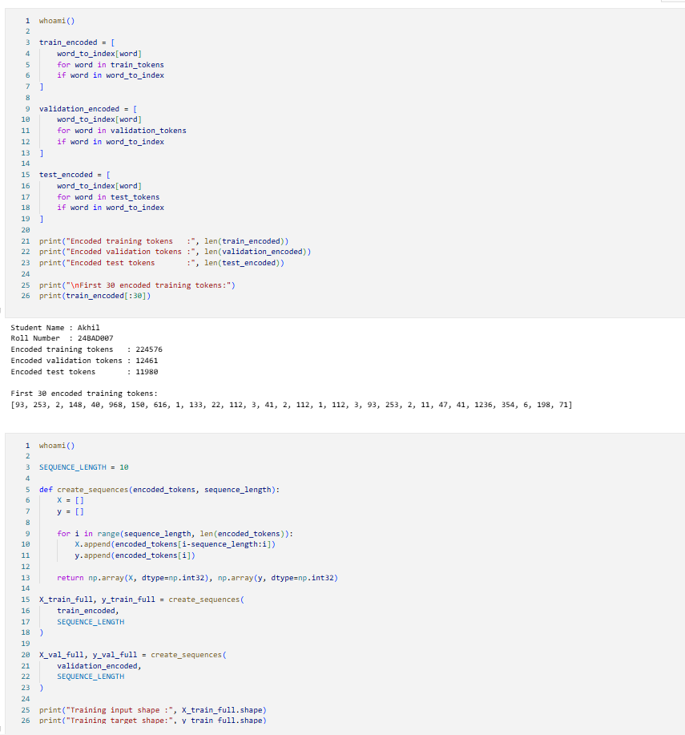
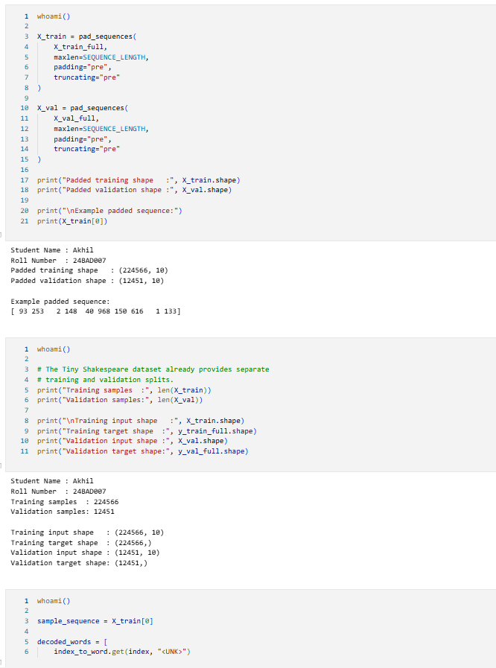
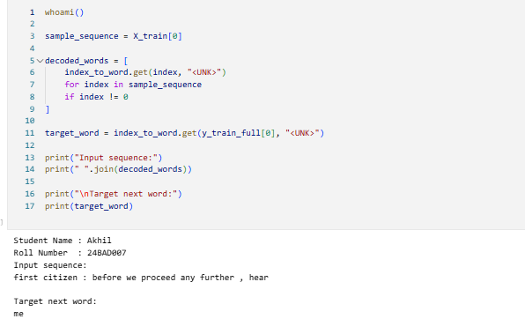

PART B: IMPLEMENTING THE RNN MODEL
Perform the following tasks:
- Create an Embedding layer to convert words into dense vector representations.
- Add a Simple RNN layer to learn sequential dependencies in the text.
- Add a Dense output layer with Softmax activation for next-word prediction.
- Compile the model using an appropriate optimizer and loss function.
- Display the model architecture and summary.

(CODE: CONATAINS STUDENT ROLL NOS
SCREENSHOT OF CODE
SCREENSHOT OF OUTPUT)

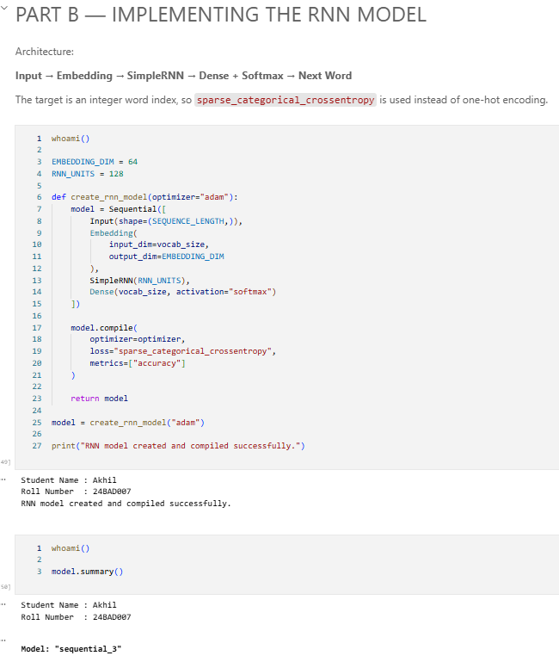
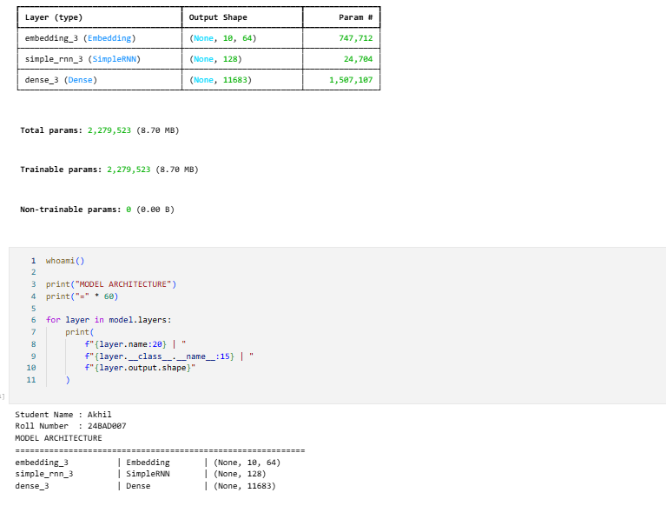

PART C: COMPARISON OF OPTIMIZATION ALGORITHMS
Perform the following tasks:
- Train the RNN model using the prepared training dataset.
- Validate the model using the validation dataset.
- Record:
  - Training accuracy
  - Validation accuracy
  - Training loss
  - Validation loss
- Visualize:
  - Accuracy vs. Epoch
  - Loss vs. Epoch

(CODE: CONATAINS STUDENT ROLL NOS
SCREENSHOT OF CODE
SCREENSHOT OF OUTPUT)

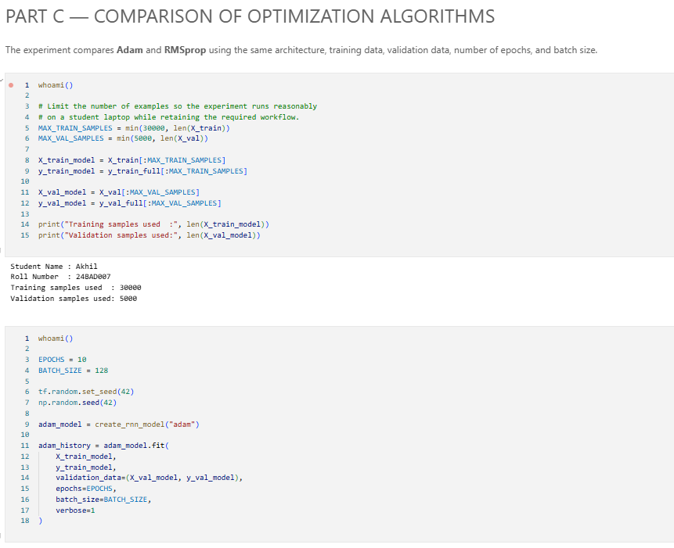
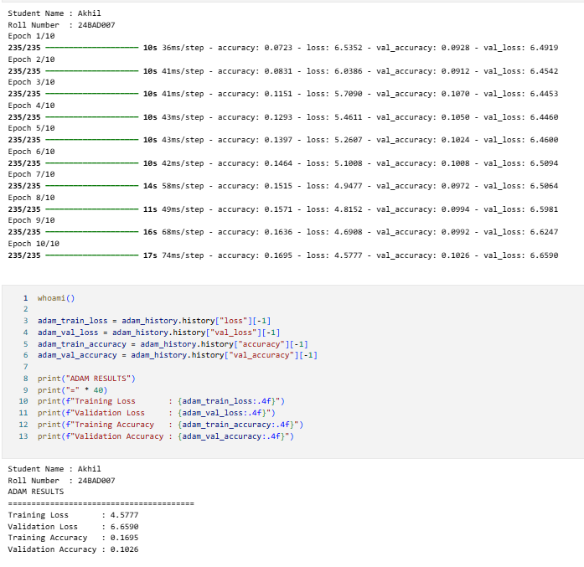
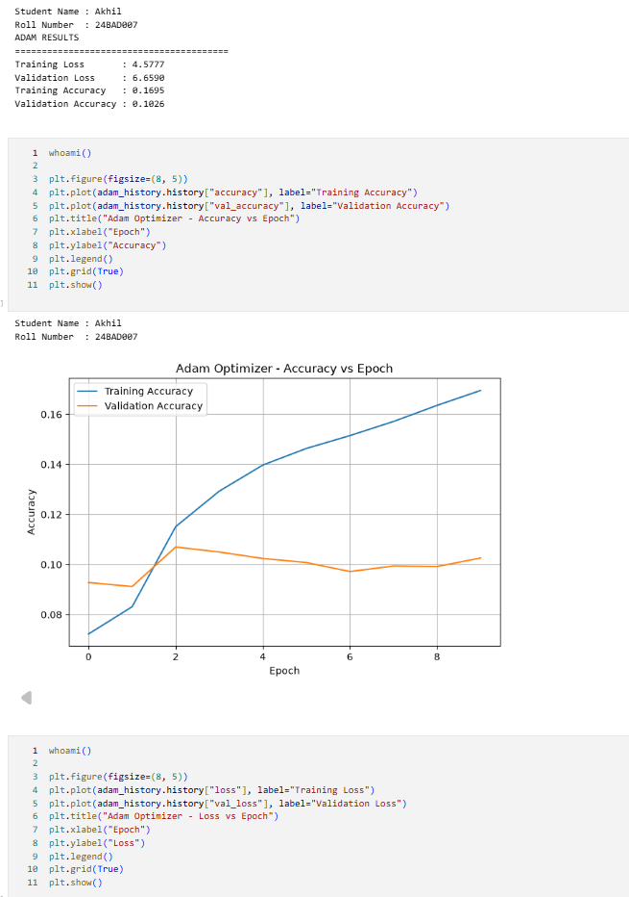
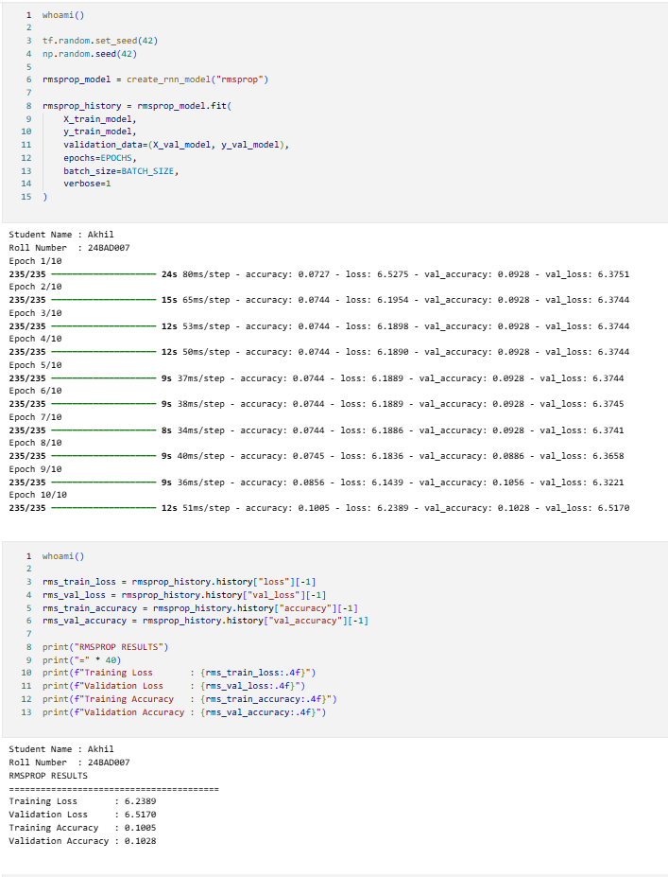
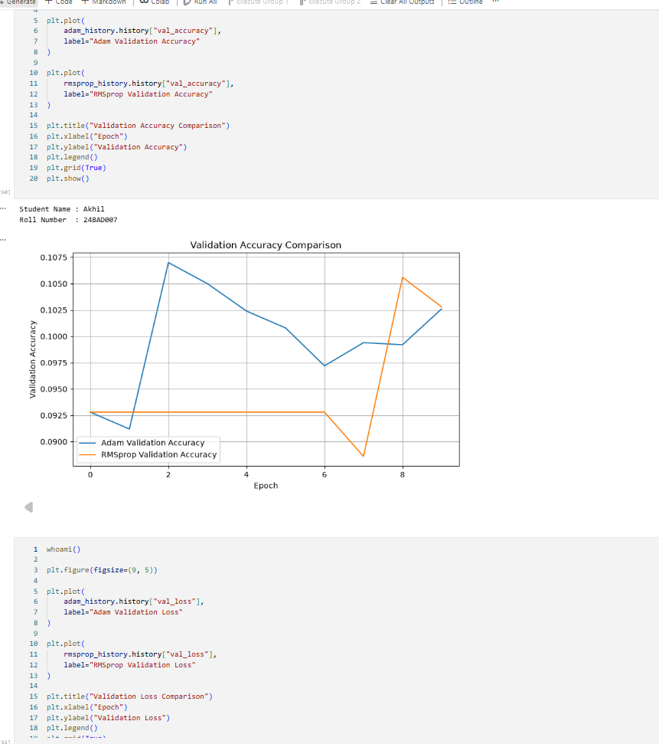
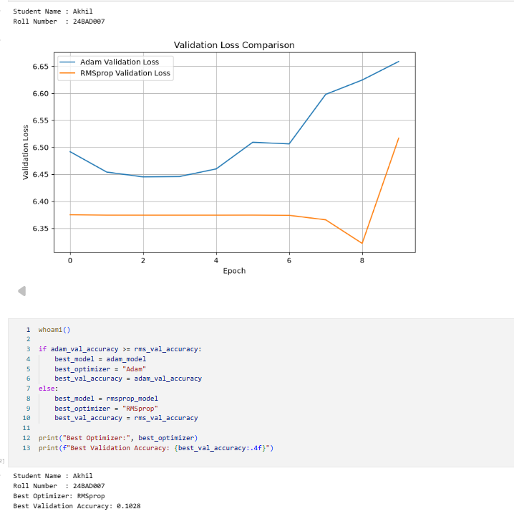

PART D: DEEP LEARNING EXPERIMENT MANAGEMENT
Perform the following tasks:
- Provide a seed word or sentence as input to the trained model.
- Generate text by repeatedly predicting the next word in the sequence.
- Produce multiple text samples using different seed inputs.
- Compare the generated text for coherence and contextual relevance.
- Document the observations and upload the notebook to GitHub.

(CODE: CONATAINS STUDENT ROLL NOS
SCREENSHOT OF CODE
SCREENSHOT OF OUTPUT)
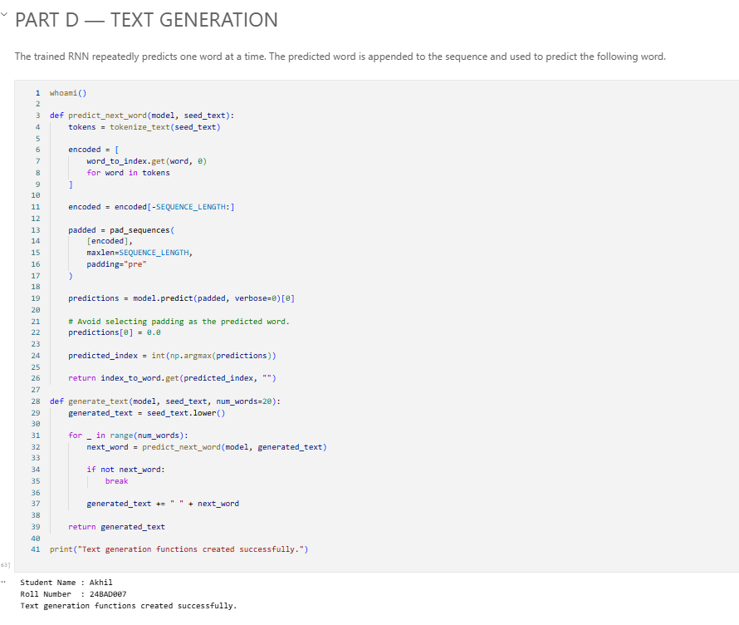
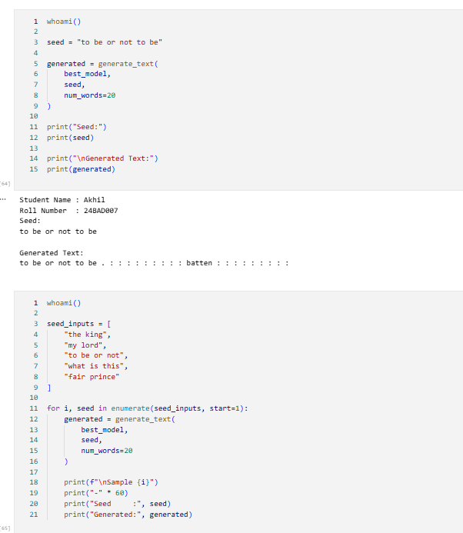
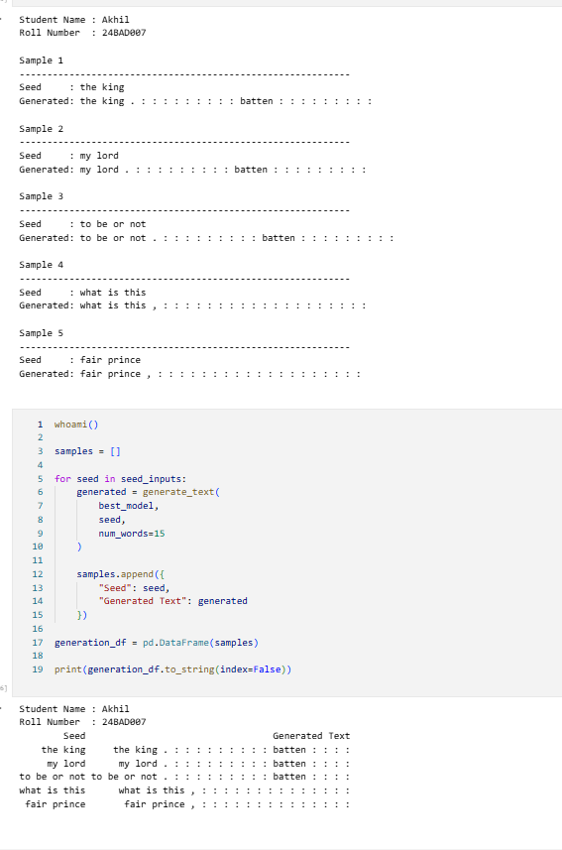

EXPECTED OUTCOME
Students will understand how an RNN learns sequential information and generates meaningful text based on previously learned patterns. Students will learn to preprocess textual data and train a Recurrent Neural Network (RNN) for text generation. They will evaluate the model's performance using training metrics and generate text through next-word prediction.

POST-LAB QUESTIONS (PROVIDE BRIEF ANSWERS TO THE FOLLOWING QUESTIONS)

- Describe the role of the hidden state in an RNN during sequence processing.
The hidden state acts as the RNN's memory. At each time step, it combines information from the current input with information from the previous hidden state. This allows the RNN to retain context from earlier parts of a sequence and use it when processing later elements.

- Discuss the effect of training an RNN model for an insufficient number of epochs.
If an RNN is trained for too few epochs, the model may not learn the important patterns in the training data. This can result in underfitting, leading to poor predictions and low-quality generated text. The model may produce repetitive, incomplete, or grammatically incorrect sequences because it has not had enough training to learn the underlying language patterns.

- Explain the purpose of padding when preparing text sequences for RNN training.
Padding is used to make sequences of different lengths equal in size. For example:
I love AI → [I, love, AI]
I love learning AI → [I, love, learning, AI]
The shorter sequence can be padded with a special value such as 0 so both sequences have the same length. This allows them to be processed efficiently together in batches by the RNN.

- Discuss one limitation of a Simple RNN when processing long text sequences.
A major limitation is the vanishing gradient problem. During training, information from earlier time steps can gradually lose its influence as the sequence becomes longer. As a result, a Simple RNN may struggle to remember important information from the beginning of a long text sequence. This makes it difficult to learn long-term dependencies.

- Discuss the effect of sequence length on the performance of the text generation model.
Sequence length determines how much previous context the model can use when predicting the next token.
Very short sequences: The model has limited context and may produce less coherent text because it cannot consider enough previous information.
Longer sequences: The model receives more context and can potentially generate more coherent and meaningful text.
Very long sequences: Training becomes more computationally expensive, and Simple RNNs may struggle with long-term dependencies due to problems such as vanishing gradients.

ASSESSMENT
Description | Max Marks | Marks Awarded
Pre Lab Exercise | 5
In Lab Exercise | 10
Post Lab Exercise | 5
Viva | 10
Total | 30
Faculty Signature

